Advanced Process Control Systems (Project Plan Outline).
Intelligent Fault Detection and Process Monitoring for Acetic Acid Production plant.
Spring 2026 – Fiyinfoluwa Abisoye – (Github Repo)
- Project Setup, Planning:
1.1 Industrial Context
- Zooming in on the chemical process automation scheme for the industrial production of acetic acid via oxidation of acetaldehyde. This plant includes oxidation column, reactor, plate packed distillation column, separators, scrubber, evaporator, boiler system, storage tanks, pumps, heat exchangers, and full instrumentation / control layers (FT, PT, TT, LT, FIC, PIC, TIC loops – see attached VSD file separately).
- This process is: Multivariable, Nonlinear, highly coupled, and safety-critical (oxidation reaction + steam systems).
  - TEPSD (Tennessee Eastman Process simulation dataset) would be highly beneficial to simulate-reactor-separator-recycle structures. I’ll use these datasets because it:
- Models a complex chemical plant
- It contains reactors, separators, compressors, and recycle loops.
- Includes manipulated variable and process measurements.
- Provides labeled fault scenarios
- Simulates real industrial noise and disturbance
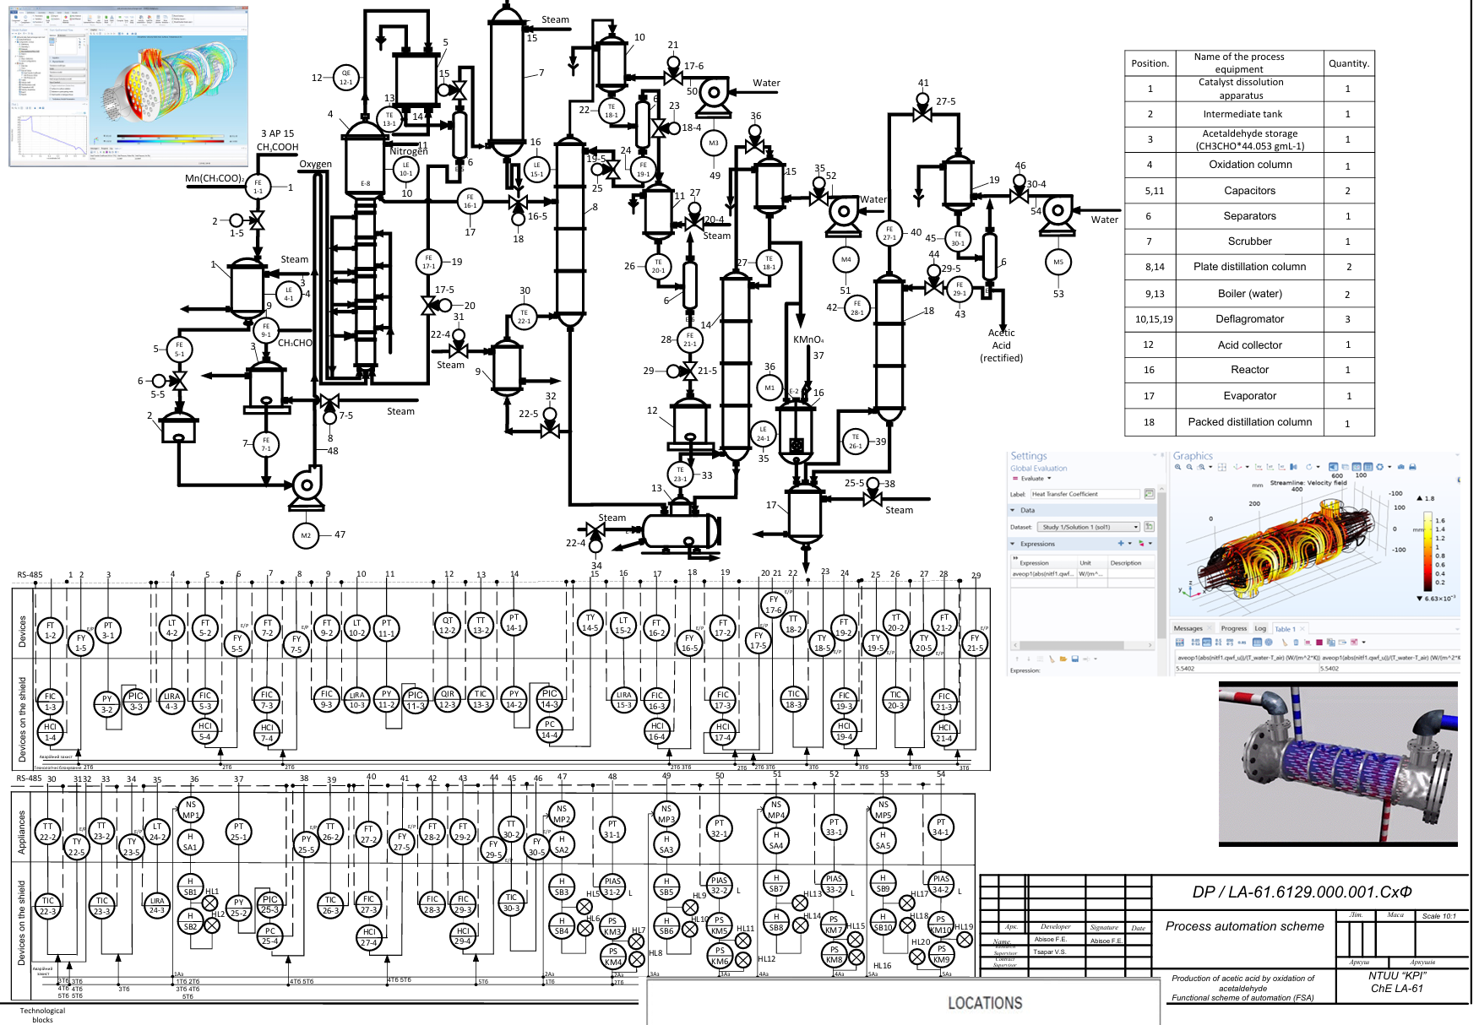
Process Equipment | Tennessee Eastman Equivalent
Reactor | CSTR Reactor
Distillation Columns | Stripper / Separator
Scrubber | Vapor-liquid separator
Heat exchangers | Condenser/Cooler
Control loops (FIC, TIC, PIC) | Manipulated variables

Therefore, the TE dataset serves as a digital twin proxy for implanting intelligent monitoring for my real plant configuration.
- Dataset Unsupervised and Supervised tasks - As my automation scheme includes:
- 50+sensors (flow, temperature, pressure, level)
- Multiple feedback loops
- Actuators (valves, pumps, steam inputs)
- Interconnected dynamics
Choosing these dataset Tennessee Eastman Process Simulation Dataset creates two major ML opportunities. Both Unsupervised (realistic for plant deployment) and Supervised applications (research and optimization).
- Exploratory Data Analysis (EDA) Justification
To really justify data selection, we perform
3.1. Sensor Count & Dimensionality – 41 measured variables (xmeas) | 11 manipulated variables (xmv)| 52 total variables
3.2. Correlation Analysis – (Multivariate correlation patterns) – Strong correlation between temperature and pressure, coupling between reactor and distillation, then steam input affecting multiple units.
3.3. Fault Pattern Visualization – Fault cases would show gradual drifts (as in catalyst deactivation), sudden jumps (valve failure), oscillatory behavior (control instability).
4. Proposed Tools and Methods.
4.1 Data Pre-processing: It is needed to implement Standard Scalar (important due to
Magnitudes), train/test split by simulation run, time-window segmentation.
  - Unsupervised Methods (PART 2)
- PCA Monitoring – (This is to detect abnormal oxidation column tempt. behavior
- Dimensional reduction.
- SPE (Squared Prediction Error).
- Hotelling’s T² control charts.
- Autoencoder – (Deep Learning - To detect steam imbalance or reactor instability)
- This would help learn operation manifold.
- And to reconstruct errors as anomaly score
  - Supervised Methods (PART 3)
- Random Forest
- Baseline multiclass classifier
- Feature importance analysis
- Gradient Boosting (XGBoost)
- High Performance
- Better nonlinearity handling
- LSTM – captures time dependencies and models dynamic reactor behavior

Tentative deadline | Task
Wk 1 (27/February) | Study automation scheme + map variables to TE
Wk 2-3 (6/March) | Data cleaning & EDA | PCA-based monitoring system
Wk 4-5 (13/March) | Autoencoder anomaly detection | Supervised fault classification
Wk 6 (20/March) | Comparative analysis & visualization
Wk 7-8 (27/March) | Industrial interpretation (mapped to acetic acid plant) | Final report & presentation

